Final project Windows Server 2022

Introduction
This document created by IT manager Ofri Peretz.
This document's purpose is about the Peretz Industries, and its include the network topology of both sites of the company: main site in Tel Aviv, Israel. Second site in New York, USA. Shows the creation of all servers in each site.
1. Two Hyper-V server, Each Hyper-V server contains several VM's
2. Two Active Directory + DNS server, one in each site.
3. Two DHCP servers, one in each site.
4. Two IIS servers, one in each site.
5. Two File servers, one in each site.
6. CA server.
7. Four RDS servers, two in each site.
Also it include all the policies for each group of department, IP addresses.
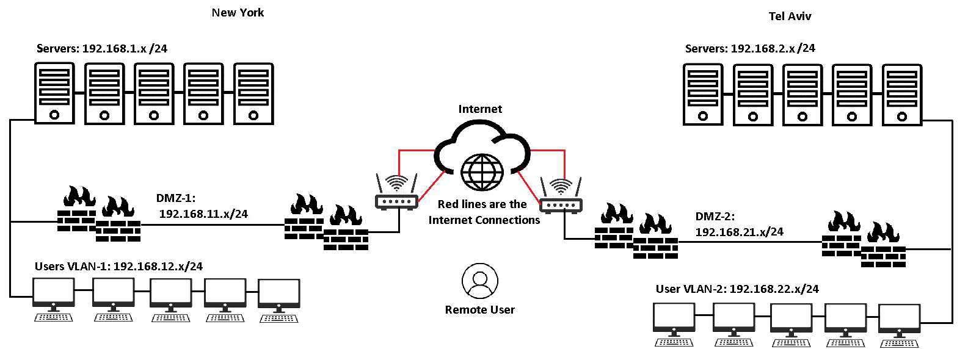

3. ADDS

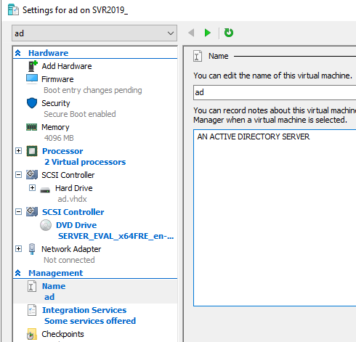

First of all we’ll create a AD server. We’ll create a virtual machine named: ‘AD1’.
2 CPU, 55B HD, 4GB RAM (Dynamic memory), OS: Windows server 2022, connected to an internal switch. We have called the PC “ad” and set the IP address to: 192.168.1.2
Domain name will be: PeretzIndustries.com
This AD server is also being used as a DNS.
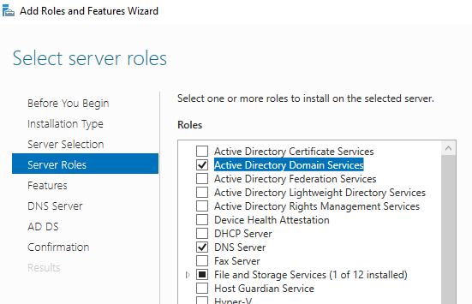

At the server manager, under “Manage” tab we’ll click on “Add Roles and Features”. We’ll add to our VM two different roles, first will be Active Directory Domain Services and DNS Server.
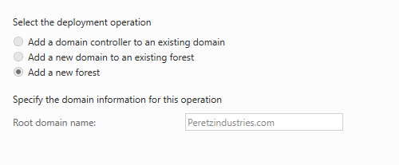
After completing installation I’ll be finishing the latest touch with the domain and install it completely.
Domain name: “Peretzindustries.com”.
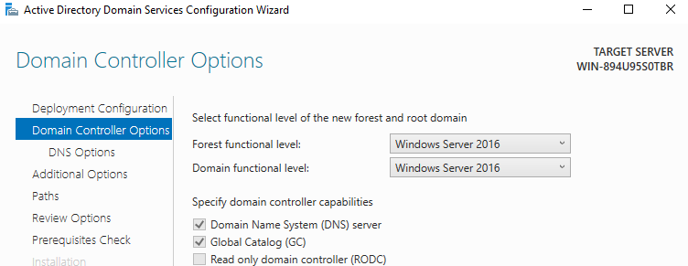
This version of our AD will be “Windows Server 2016” due to it being the latest version for Active Directory servers.
After we finished creating our Active Directory server, we will create another active directory server as backup.
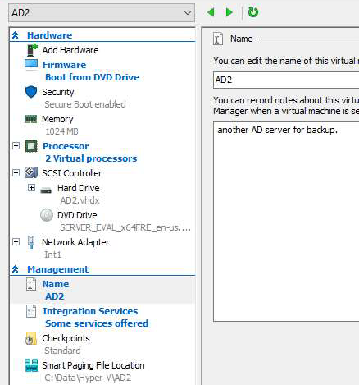
Establishing a second AD server, we’ll create another virtual machine named “AD2”.
In this virtual machine we’ll be setting: 2 CPU, 50GB HD, 1GB RAM with dynamic memory and an operating system of Windows Server 2022 connected to an internal switch.
We will then install the feature “Active Directory Domain Services”.
And we will then call the PC “AD 2” and set the IP address to: 192.168.1.3
Before we upgrade the DC, we add the DNS address 192.168.1.2
We will then choose the first option: “Add a domain controller to an existing domain”.
Right after we’ll write our domain name and administrator user name, Press “Next” and we will join our domain as another Active Directory server that will synchronize with our main Active Directory server.

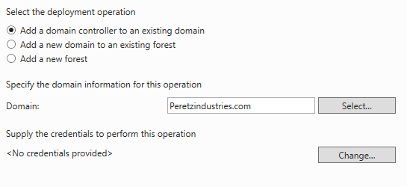

a. The Organization Unit Topology
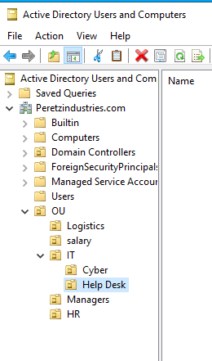
We will now focus on creating our OU topology. We will open the Active Directory Users and Computers, right click on “Peretzindustries.com”, press “New” and add a new organization unit named “OU”. Then, under this organization unit we will add all the relevant units for our company based on our company’s tree: Logistics, Sales, IT and more. Under every department we’ll create more units for example, under IT we’ll do: “IT Managers”, “Help Desk” and more.

b. Sites and Services
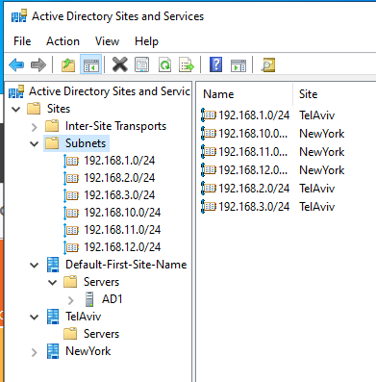
In the active directory server we will open the “Active Directory Sites and Services” tool, in the following tool we’ll create our sites: “Tel Aviv” and “New York”. In this tool we can manage our subnets and attach them to each site.

c. Group Policy.
In this scenario our company has 1,000 employees. In order to create 1,000 users in the most efficient way we will be writing a script to create these ADUsers from a CSV file.
import-Module ActiveDirectory
$ADUsers = Import-csv -Path C:\temp\users.csv -Delimiter ','
$UPN = "Peretzindustries.com"
foreach ($User in $ADUsers) {
$username = $User.username
$password = $User.password
$firstname = $User.firstname
$lastname = $User.lastname
$initials = $User.initials
$OU = $User.ou
$email = $User.email
$streetaddress = $User.streetaddress
$city = $User.city
$zipcode = $User.zipcode
$Country = $User.state
$telephone = $User.telephone
$company = $User.company
if (Get-ADUser -Filter { SamAccountName -eq $username }) {
Write-Warning "A user account with username $username already exits in
ActiveDirectory."
}
else{
Write-Host -Object "Name: $($username)"
New-ADUser `
-Path 'OU=OU,DC= Peretzindustries,DC=com' `
-Name $username `
-SamAccountName $username `
-GivenName $firstname `
-Surname $lastname `
-Initials $initials `
-DisplayName "$lastname, $firstname" `
-City $city `
-StreetAddress $streetaddress `
-PostalCode $zipcode `
-Company $company `
-OfficePhone $telephone `
-EmailAddress $email `
-UserPrincipalName "$username@$UPN" `
-AccountPassword (ConvertTo-SecureString $password -AsPlainText -Force)
-ChangePasswordAtLogOn $True `
-Enabled $True `
-state $Country `
Write-Host "The user account $($username) was created." -
ForegroundColor Cyan
}
}
Read-Host -Prompt "Press Enter to exit"
The results will be as put below:

d. Password policy and complexity.
In the following note we will be setting the password policy, complex, 5 histories, maximum 90 days and lock after 3 attempts for 30 minutes.
First of all we’ll need to open the “Group Policy Management” console, open our forest and then our “Domain”. Now, in the domain section we will move to “Group Policy Objects” and edit the “Default Domain Policy”.
Under our path: “Computer Configuration\ Policies\ Windows Settings\ Security Setting\
Account Policies\ Password Policy” we will change the password policy.
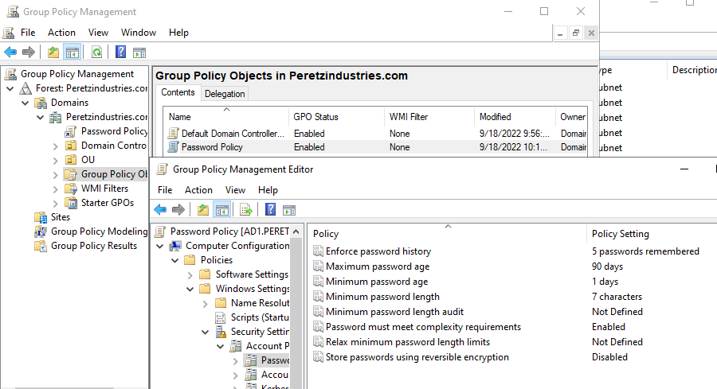

4. IP addresses management (DHCP).
Our company will have 2 different yet very similar, each DHCP server will serve each site (New York and Tel Aviv). We will start from creating the first server for and in Tel Aviv, the machine will be named “DHCP”.
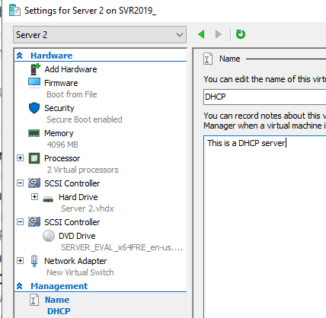
We will create the DHCP server and name the machine in Hyper-V DHCP.
In the machine we’ll set the following: 2 CPU, 55GB HD, 4GB RAM with dynamic memory and an operating system of Windows Server 2022 connected to an internal switch. We’ll rename the PC’s name to “DHCP” and join the domain.
We change the DNS to 192.168.1.2 and our alternate DNS to 192.168.1.3 after we join the domain. Then we’ll do the same with another DHCP server naming it “DHCP2” for the New York branch.
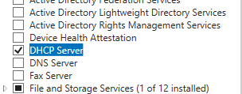
Then, on “Server Manager”, under “Manage” tab we will choose “Add Roles and Features” and choose the “DHCP Server” role. We will install the role and join the domain.
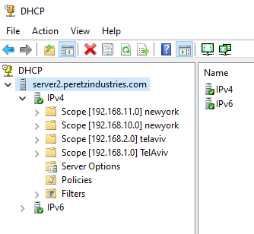
We will then add our scopes in the Tel Aviv site and add the exclusions: 192.168.1.2 and 192.168.1.3 which are our DNS IP address, then in the other DHCP server we will add New York’s scopes adding the same exclusions.
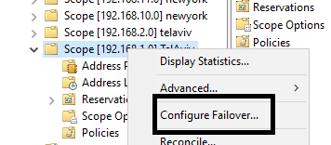
We will right click on our scope and choose “Configure failover”.
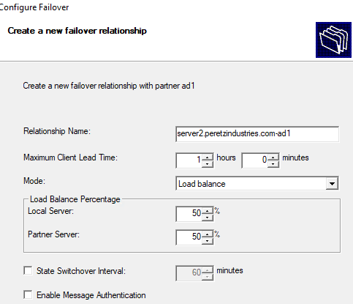
We will add our second DHCP server named “DHCP2”.
5. DNS Solution.
Because we have two sites, we will need a DNS solution for each site. With Active Directory Integrated Primary Zone, each DNS server will provide resolution to the site it’s located in as primary DNS server.
Active Directory 1 machine server:
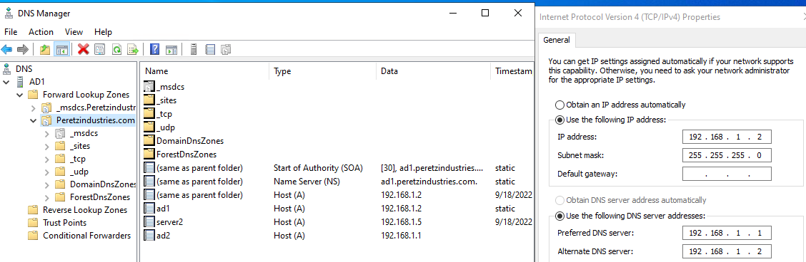

6. File service solution (DFS).
a. Divisions’ shared folders.
First, we’ll create a new machine named “File Server”.
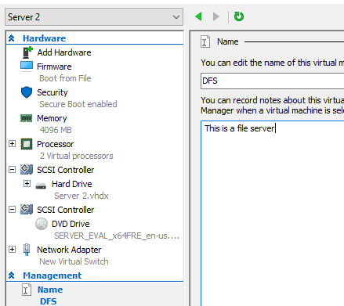
We will create the File Server, name the machine in Hyper V “DFS” and set it up as following:
2 CPUs, 50GB HD, 1GB RAM with dynamic memory and an operating system of Windows Server 2022 connected to an internal switch. We will rename the PC’s name to “DFS” and join the domain. Then we will install new features for our file server: File Server and DFS namespaces.
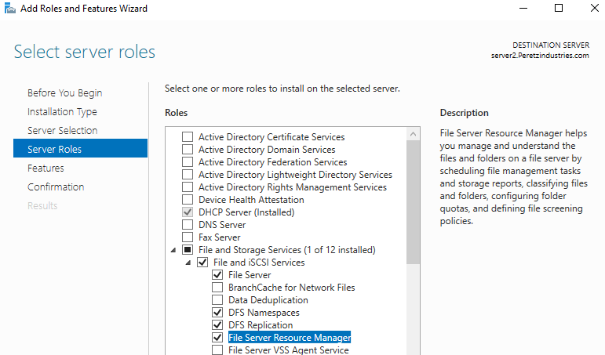
In our server, we’ll add the following roles and features:
* File and Storage Services.
* DFS Namespaces.
* DFS Replication.
* File Server Resource Manager.
While we install the roles we will create in each server a local folder named “PTShared”.
We create these folders on C Drive and we share this folder. We will then give permissions to authenticated users.
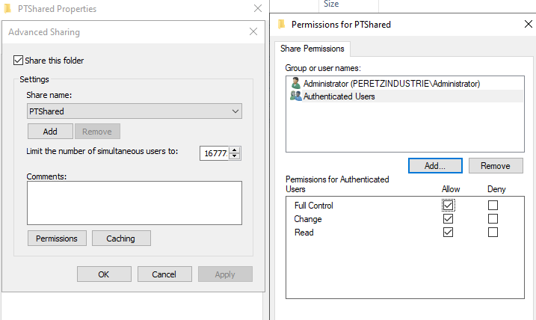
After the roles will finish installing we will open the DFS management and create a new namespace named “PTShared”.
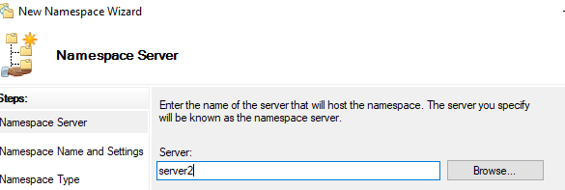

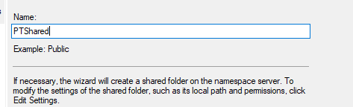
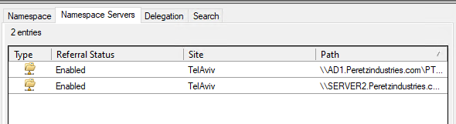
Then we add another file server with the same new folder “PTShared”.
After that we’ll make the replications between the two servers.
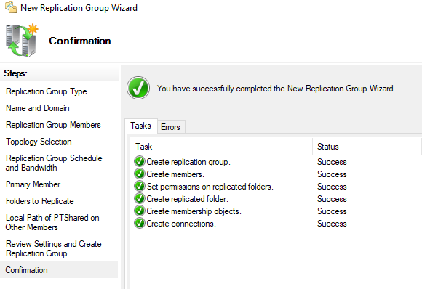
To limit each user to 500GB we’ll open “File Server Resource Manager and under the “Quota Management” tab we’ll press “Quota” and “Create Quota”.
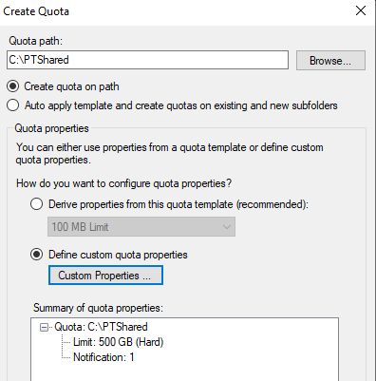
We’ll choose the path of the Quota and press “Define custom Quota properties” and limit the quota to 500 GB.
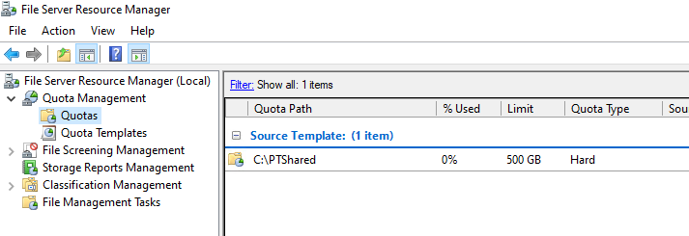
b. Employees’ drive shortcuts.
First of all, we’ll open the Group Policy Management in our active directory server. We will then create a new policy named: “PTShared on desktop”. After that we’ll then right click this policy and edit it.
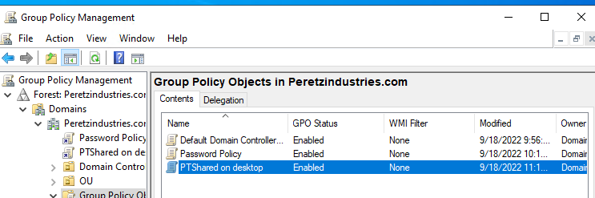
Under the path, User Configuration\Preference\Windows Settings\Shortcuts, we will create a new shortcut.
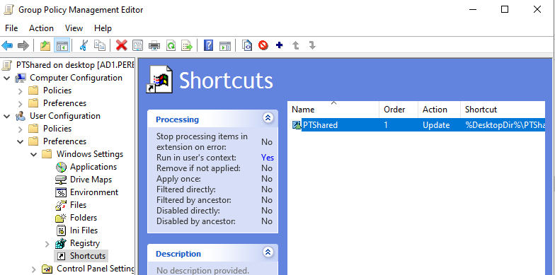
7. Account operator (help desk) and domain admins (system administrators) privileged accounts.
Every single one of our account operators and domain admins will have privileged accounts that will be identified as “a_account” with passwords expiring after 60 days and length of 12 characters (FGPP).
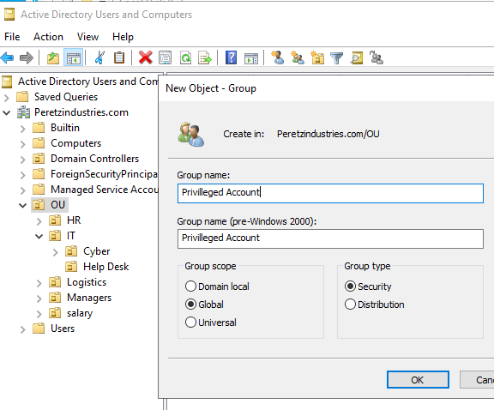
First, we’ll open the “Active Directory Users and Computers” and create a new group under “OU” named “Privileged Account”.
After that, in the Active Directory Administrative Center, under the following path: ADAC/peretzindustries(local)/system/password settings container and we edit the FGPP. We then add our new security group “Privileged Account”.
8.ADCS: Auto Enrolled Certificates.

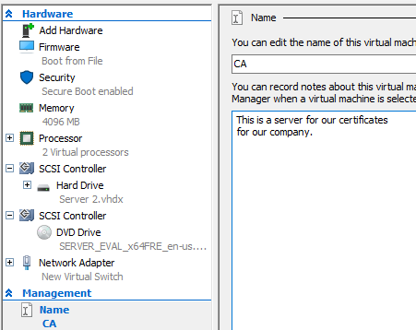
At first we will install a new role: Active Directory Certificate Services.
Then we configure the role services:
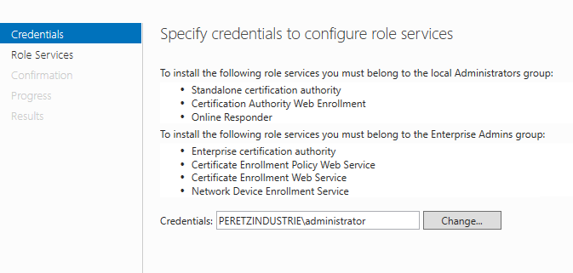
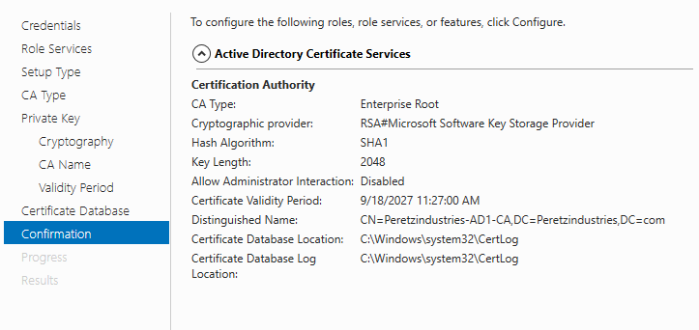
After we finish configuring the role, we open the certsrv.msc. Then we’ll right click the file “Certificate Template” and choose “Manage”.
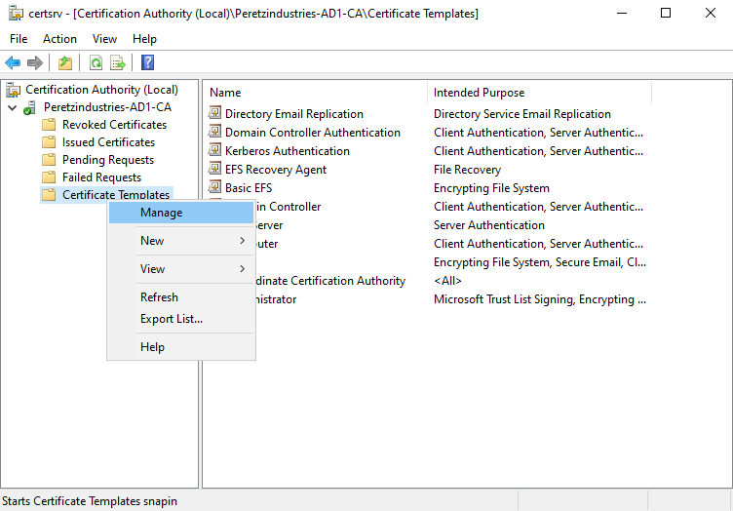
We will then right click on “User” and choose “Duplicate Template”.
Under the “General” tab we write the template’s display name:
Auto Enrolled Certificate and press “Apply”.
Under the tab, “Security” we give the domain users permissions for “Autoenroll” and we press apply.
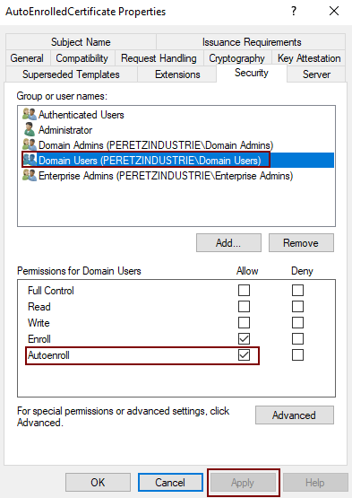
Under the “Extensions” tab we edit the “Application Policies” add “Server Authentication” and press apply.
We will then open the “Local Group Policy Editor”, under the path: User
Configuration/ Windows Settings/ Security Settings/ Public Key Policy we will choose the certificate service client – Auto enrollment and make it enabled.
We do the same with the computers, we then open the “Local Group Policy Editor” again and under the path “Computer configuration / Windows Settings/ Public Key
Policy” we choose the certificate service client – auto enrollment policy and make it enabled as well.
9.Intranet portal: Static web site.
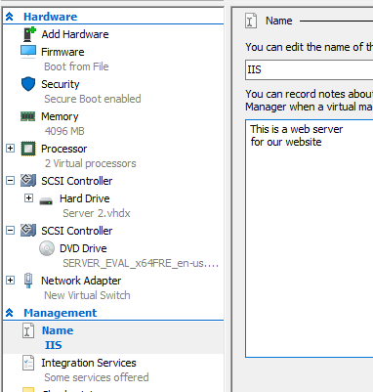
First we create our web server, we’ll create a virtual machine in Hyper-V named “Web Server” with the following settings: 2 CPUs, 55GB HD, 1GB RAM with dynamic memory and an operating system of Windows Server 2022 connected to an internal switch. We will then rename our PC to “Web Server” and join the domain. We also set a static IP which will be 192.168.1.4
After clicking on “Manage” in “Server Manager”, we choose “Add Roles and Features” and install a new role to our server: “Web Server (IIS)”.
We then open the file wwwroot under the C:\\inetpub\wwwroot path and add the relevant files for our website. We will then give permissions to our website portal.html and then we can finally open the website at any of our servers with the IP address: 192.168.1.4
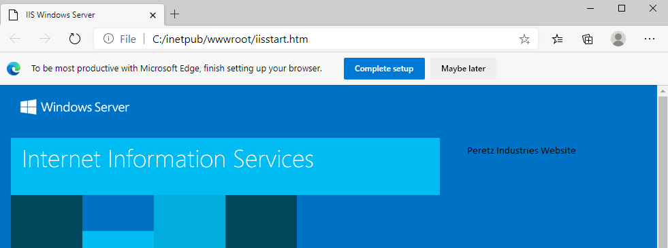
10. Management station.
For security reasons, privileged accounts will manage the different systems from a secure RDS.
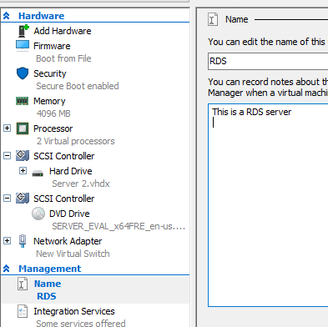
First, we will create an RDS server. We will name the machine “RDS” in Hyper V and set it up with the following: 2 CPUs, 50GB HD, 1GB RAM with dynamic memory and a Windows Server 2022 operating system with an internal switch. We will then rename the PC’s name to “RDS1” and join the domain we’ll give it a static IP of: 192.168.1.6
We install the RDS role with three services:
*Remote desktop connection broker.
*Remote desktop session host.
*Remote desktop web access.
The installation will be:
*Add roles and features.
*Remote desktop services installation.
*Quick start.
*Session based desktop deployment.
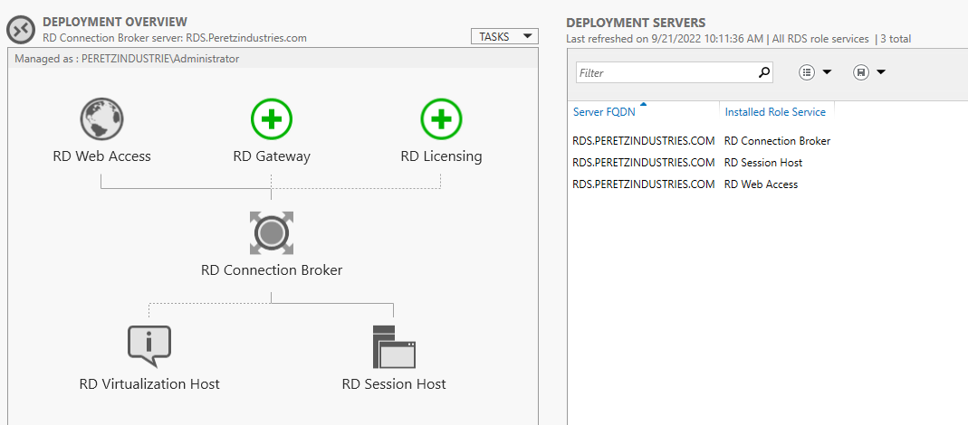
11. Backup Solution.
First things first we need to know that in this process we’ll make our domain controllers will run a weekly backup.
So, we’ll first download the the feature: “Windows Server Backup”.
Then we open “Windows Server Backup” and right click “Local Server”. We will then choose the option of “Backup Schedule”.
We set the backup to happen every day in 12:00 AM and then the backup will save in our shared folder: “PTShared”.

